USER MANUAL
BARANGAY HEALTH CENTER INFORMATION MANAGEMENT SYSTEM

Version 1.0
Prepared by: Stefane Cerezo, Hazel Sebastian, Louisse Glaze Villarente
University of La Salette, Inc.

SYSTEM OVERVIEW
The Barangay Health Center Information Management System (BHCIMS) is a centralized information system developed to support the recording, management, monitoring, and reporting of health-related data of barangay residents. The system replaces manual record-keeping with a structured digital platform, improving efficiency, data accuracy, accessibility, and security.

BHCIMS categorizes residents according to age groups and health conditions, allowing health personnel to easily track medical records, generate reports, and maintain updated reference data. The system is designed to support daily health center operations while complying with data privacy and security standards.

HARDWARE AND SOFTWARE REQUIREMENTS

2.1 Hardware Requirements
- Desktop or Laptop Computer
- Minimum of 4 GB RAM (8 GB recommended)
- Intel Core i3 Processor or higher
- Keyboard and Mouse
- Printer (for report generation)

2.2 Software Requirements
- Microsoft Windows 10 or later
- Barangay Health Center Information Management System (Installed)
- XAMPP (installed and properly configured)
- PDF Reader for viewing exported reports

USER ROLES AND ACCESS LEVELS
USER ROLE | DESCRIPTION OF ACCESS
Administrator / Midwife | Full access to all system modules, including resident records, reports, reference data, user management, and system logs
Barangay Nutrition Scholar (BNS) | Access to resident masterlists, maternal and child health records, and reports
Barangay Health Worker (BHW) | Access to adding residents and viewing and updating health records

Access to system functions is controlled through role-based permissions.

4. ACCOUNT REGISTRATION AND LOGIN PROCEDURES
4.1 Account Registration
User accounts are created and managed by the System Administrator or the Midwife. Individual users are provided with login credentials upon account creation.

4.2 Login Procedure
- Open the BHCIMS application.
- Enter the assigned Username and Password.
- Select the Log In button.
- Upon successful authentication, the system displays either an error message or a success message before displaying the appropriate dashboard based on the user's role.
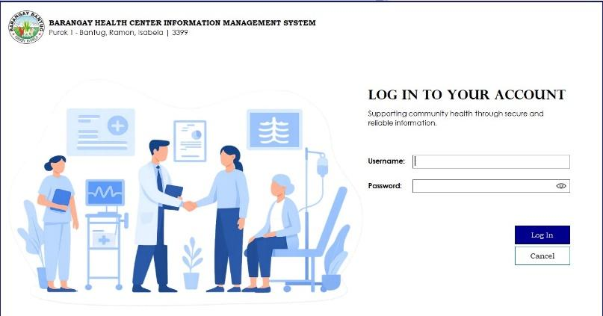



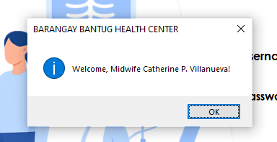


SYSTEM USAGE AND OPERATIONAL PROCEDURES
This section provides step-by-step instructions for using the system’s core features. Procedures are based on the actual system workflow and interface.

5.1 Dashboards
After logging in, users are redirected to a dashboard corresponding to their role:
- Administrator / Midwife Dashboard – Provides access to all system modules, including masterlists, reports, reference data, user management, and system logs.
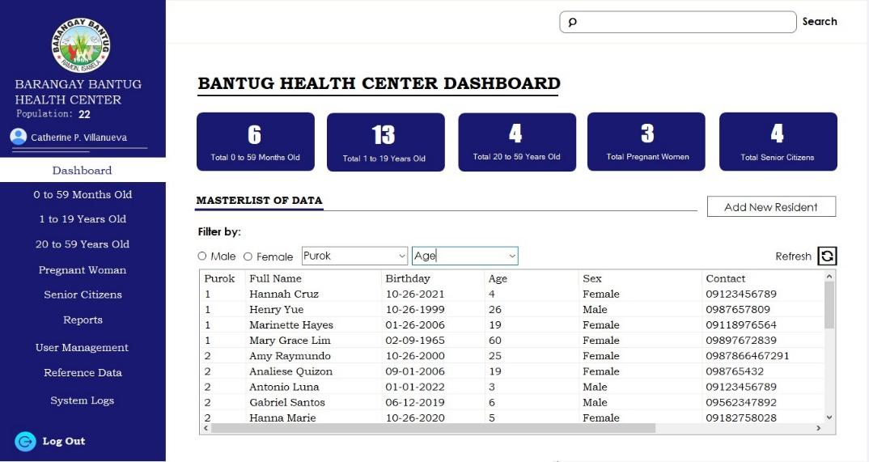

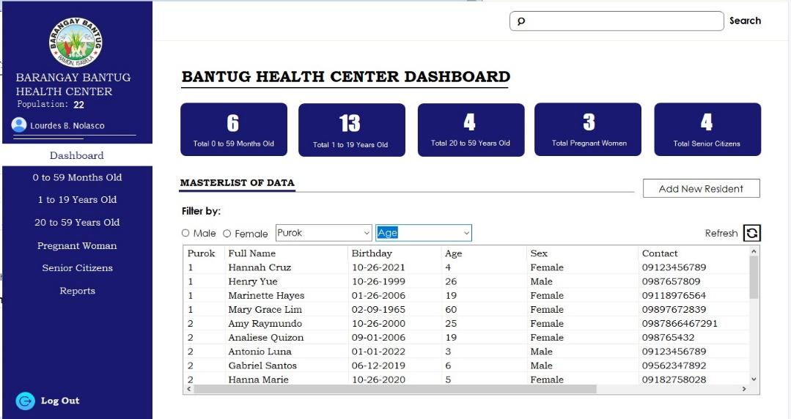
- Barangay Nutrition Scholar (BNS) Dashboard – Focuses on maternal, child, and nutrition-related records and reports.

- Barangay Health Worker (BHW) Dashboard – Used for resident registration and record updates.
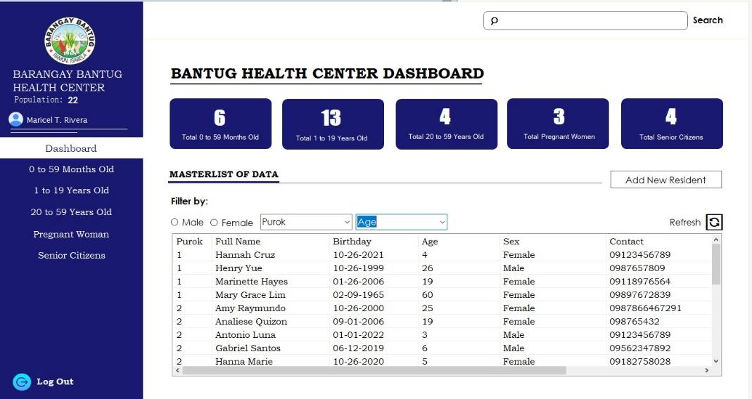

5.2 Accessing System Modules
- After logging in, locate the left sidebar navigation panel on the screen. The default screen shown is the dashboard.
- Select the desired module by clicking its name.
- The selected module will load in the main content area of the system interface.
- To exit the system, select Log Out at the bottom of the sidebar.
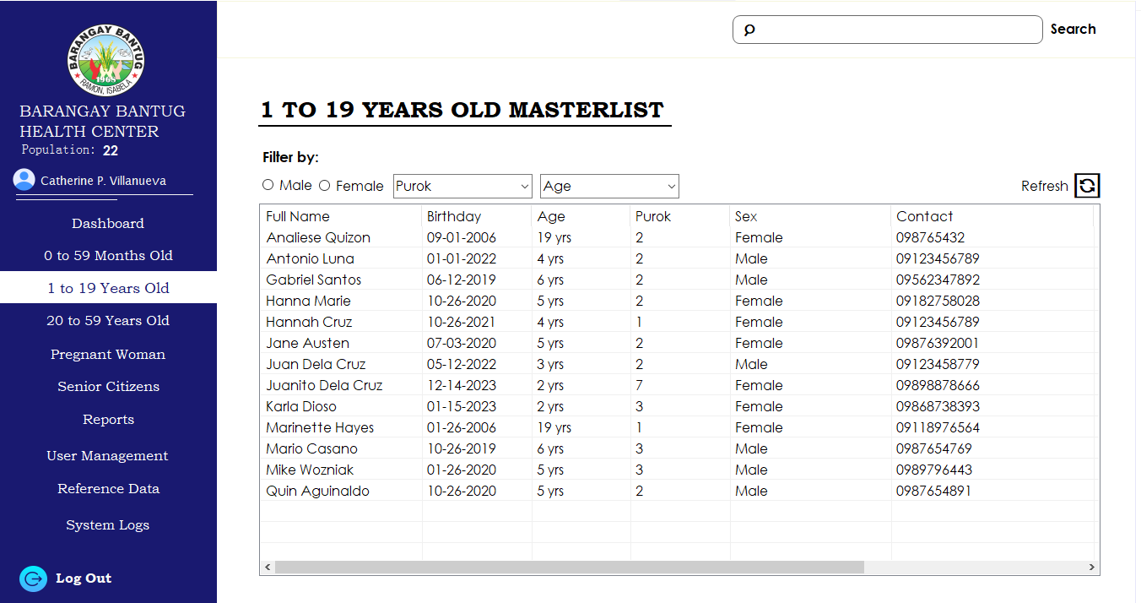

5.3 Adding a New Resident
- From the dashboard, select Add New Resident.
- Complete the required personal information fields.
- If the resident is a minor, the Guardian Information section will automatically appear.
- Select Save to register the resident.
The system automatically assigns the resident to the appropriate Masterlist based on age.
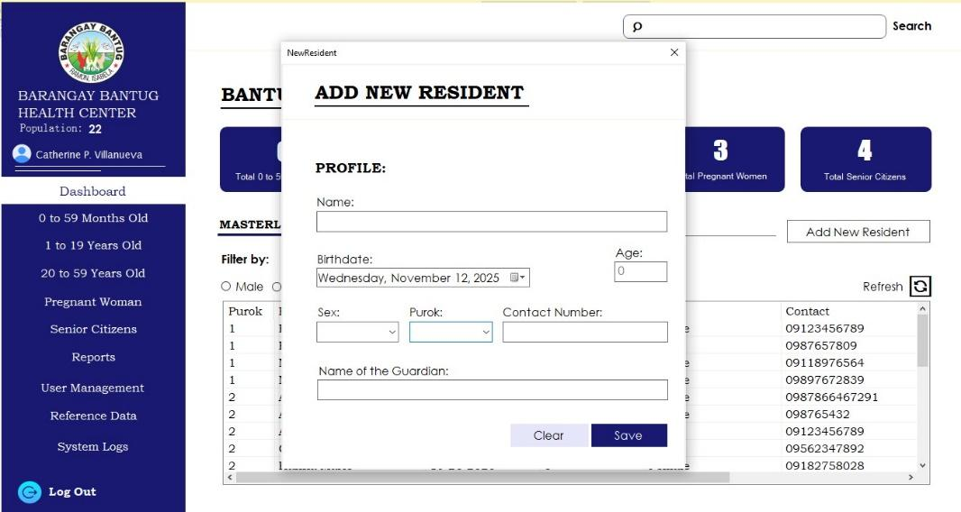

5.4 Accessing the Masterlists
General Procedure:
- From the left sidebar navigation, select the appropriate Masterlist where the system displays the corresponding list of residents.
- Locate the resident’s record in the Masterlist and double-click the selected record to open the View Details screen.
- The View Details screen shows and displays complete resident information.
- Select Edit to modify health records.
- Update the necessary fields.
- Select Save to apply the changes to the profile information.
- Navigate to the relevant tab for additional information:
- Vaccination/Nutrition tab – for 0–59 months old residents
- Medication/Vital Signs tab – for pregnant residents
- Select Add (Update for Senior Citizens Module) to include the record in the list.
- To edit an existing entry, double-click the record from the list on the right side.
- After making the necessary changes, select Save.
- Select Cancel to return to the View Details Screen.
- Select Back to return to Masterlist.
- Pregnancy Module Specific Rules
13A. Option appears only for female residents aged 10 years or older.
13B. Click the Show Past Records button to view past pregnancy records and update current health data.

5.4.1 Masterlist for Age 0–59 Years Old
This Masterlist contains records of residents aged 0 to 59 months.

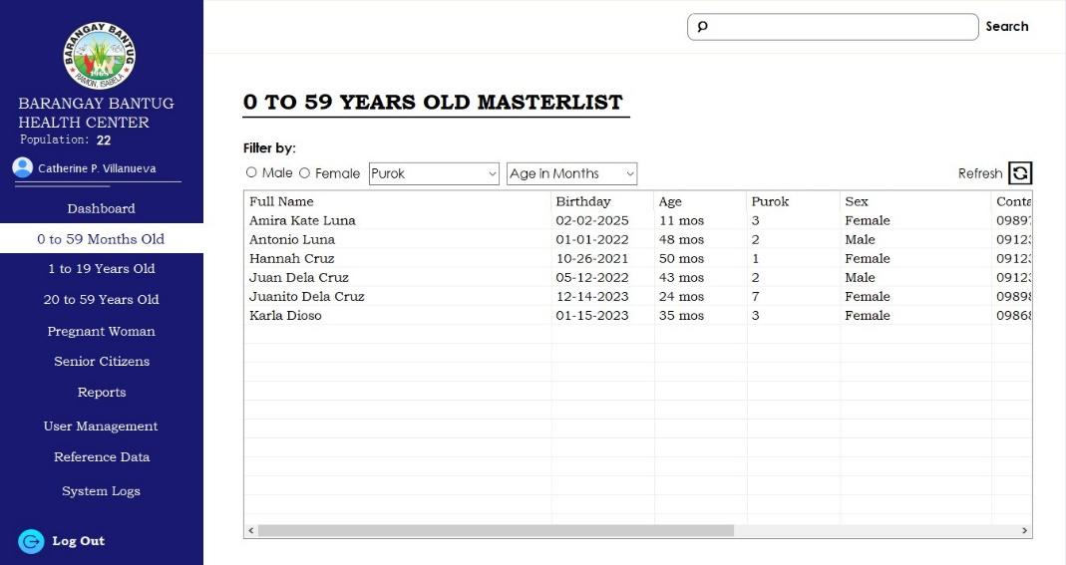

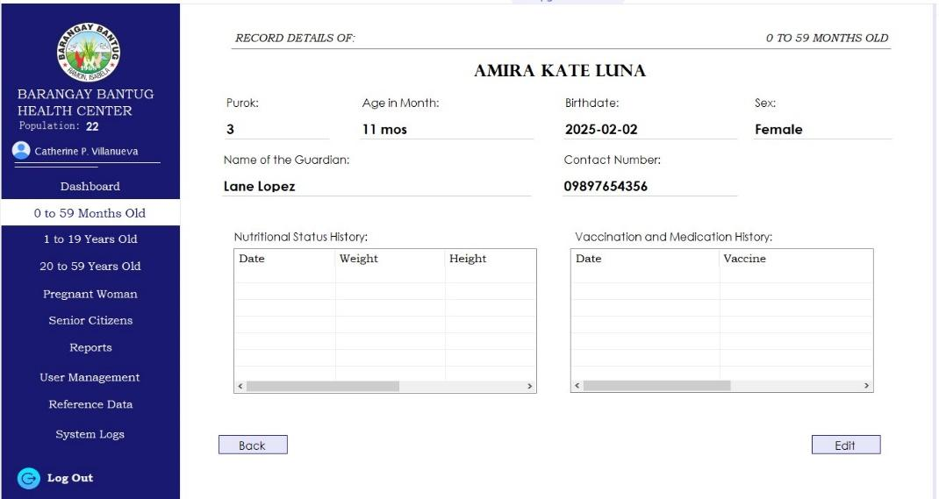

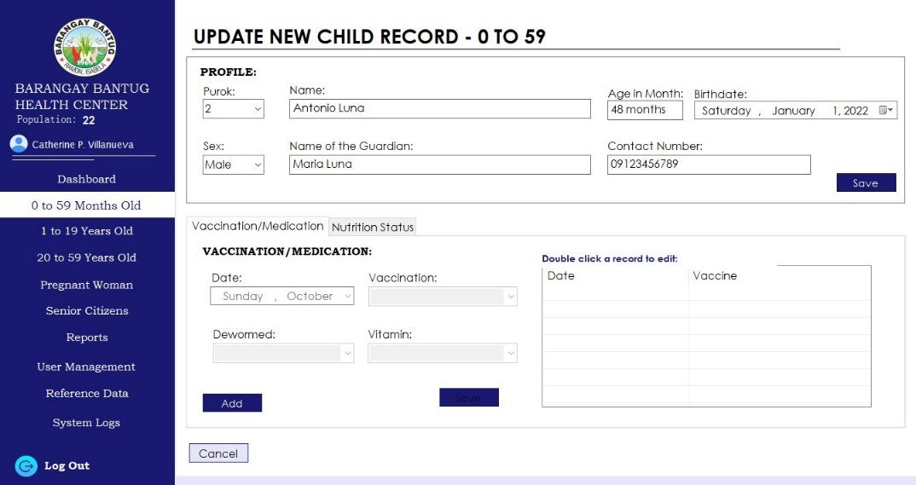

Note:
The Save button remains disabled until at least one valid input is provided.

5.4.2 Masterlist for Age 1–19 Years Old
This Masterlist includes residents aged 1 to 19 years.
Age-Based System rule
Residents aged 1–4 years are automatically redirected to the 0–59 Months module for viewing and updating.
Only residents aged 5 years and above may be viewed and updated within this Masterlist.

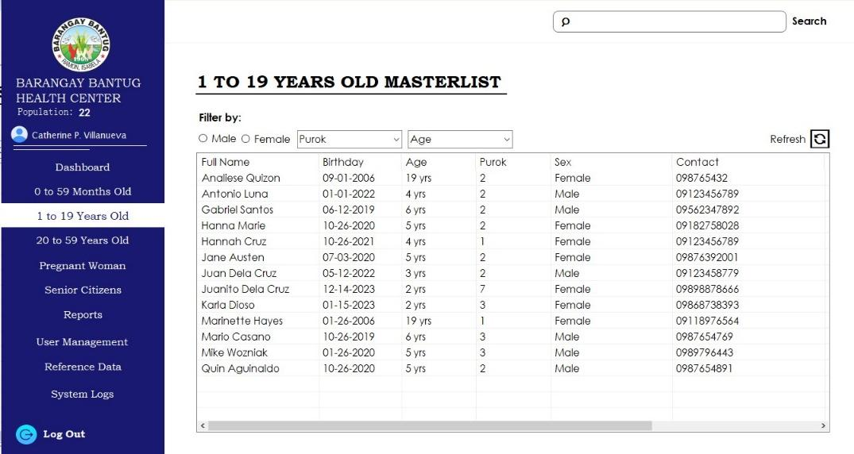

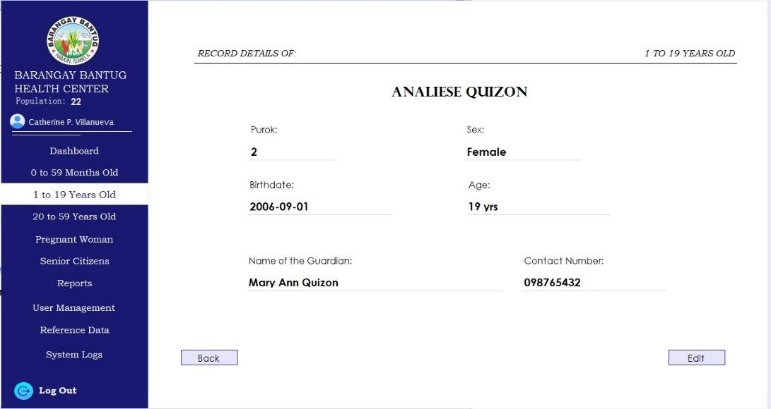

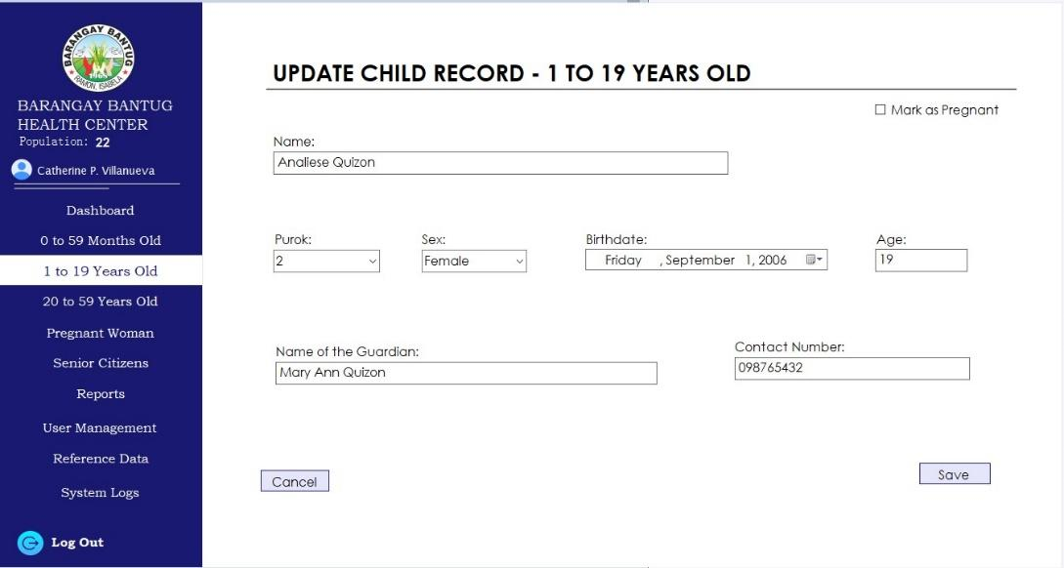
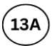

5.4.3 Masterlist for Age 20–59 Years Old
This Masterlist displays residents aged 20 to 59 years.

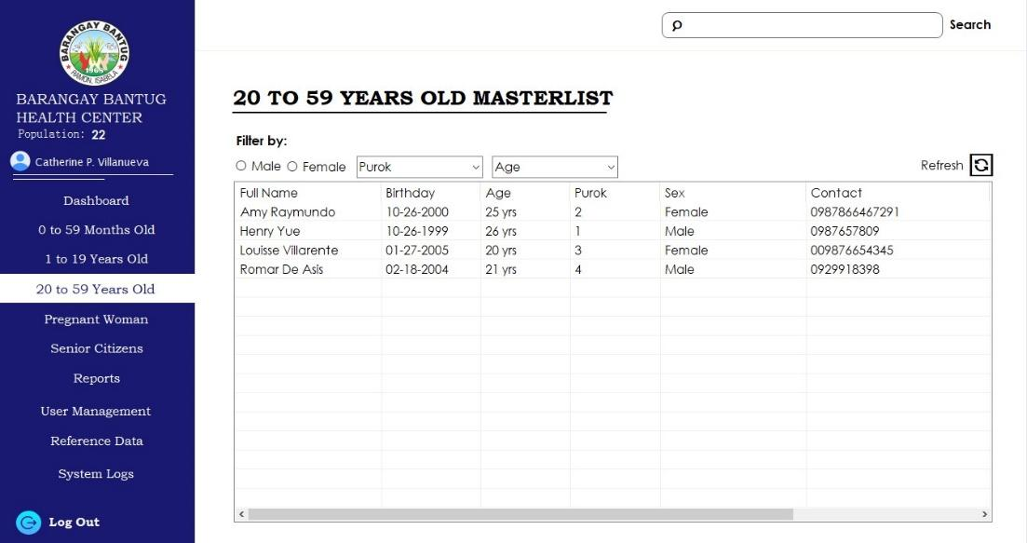

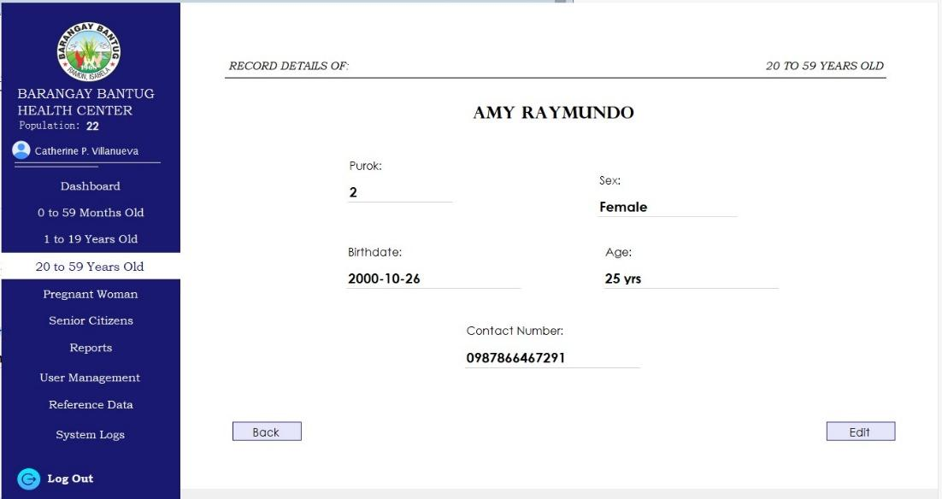

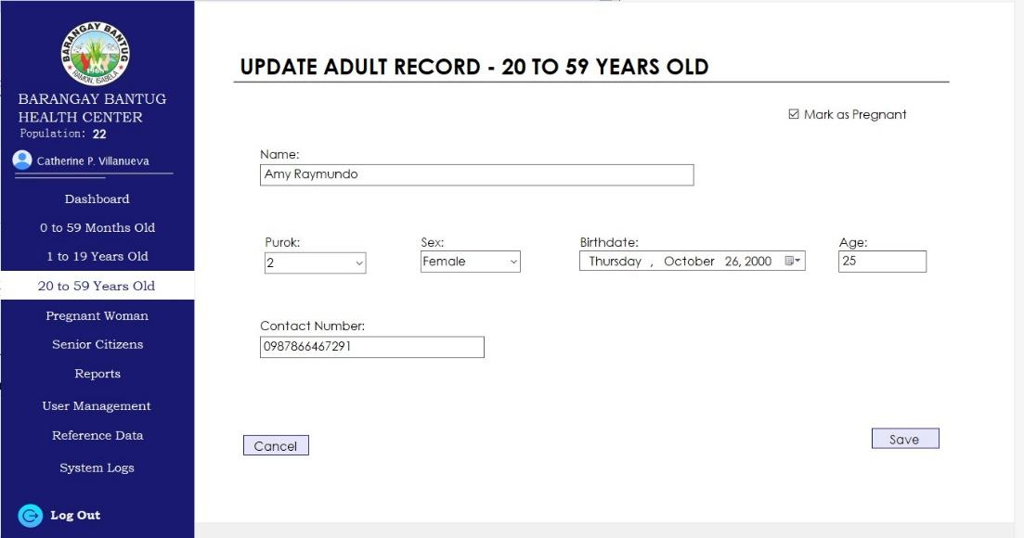
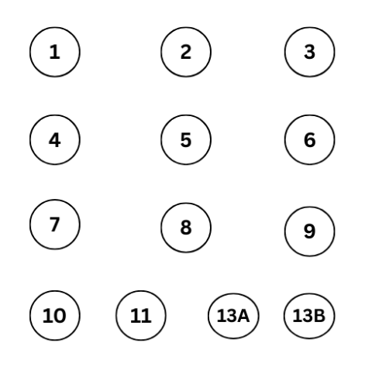

5.4.4 Masterlist for Pregnant Women
This module lists residents classified as pregnant.
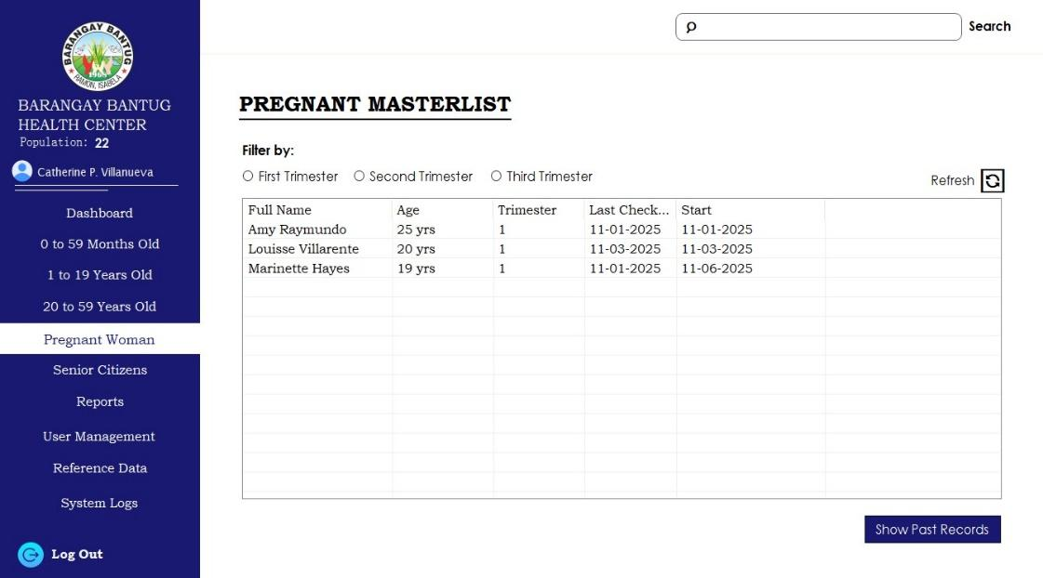

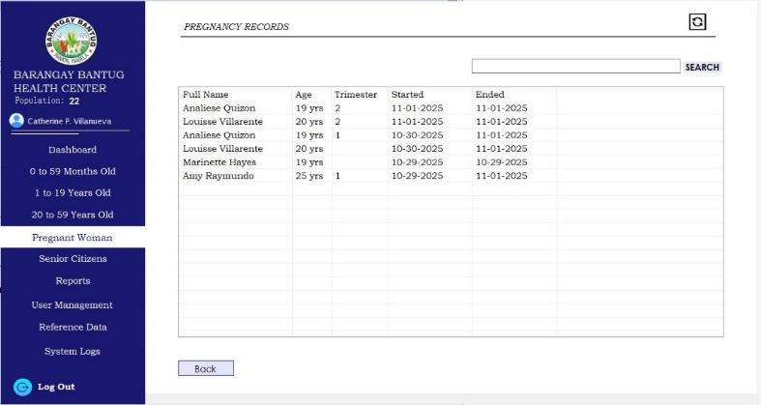

Note: This is only for viewing past pregnancy records and updating current health data.

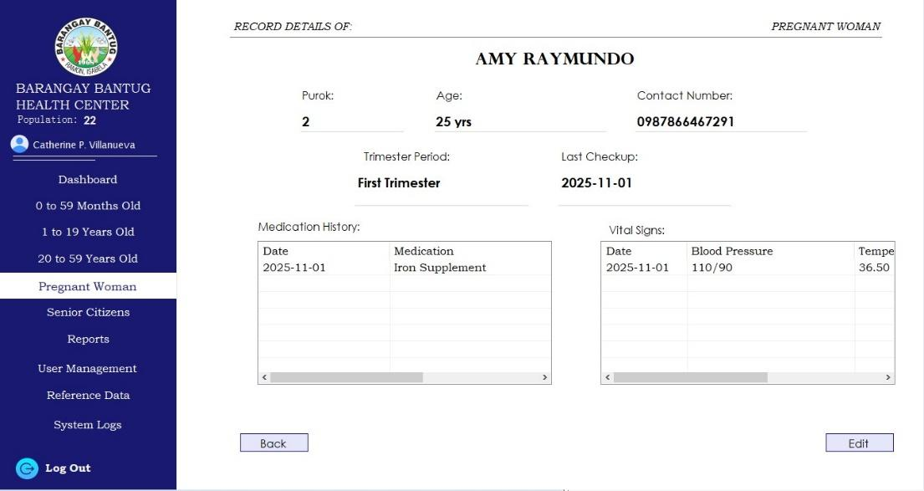

Note: The End Pregnancy button marks the completion of an active pregnancy record and automatically removes the resident from the Masterlist for Pregnant Women.

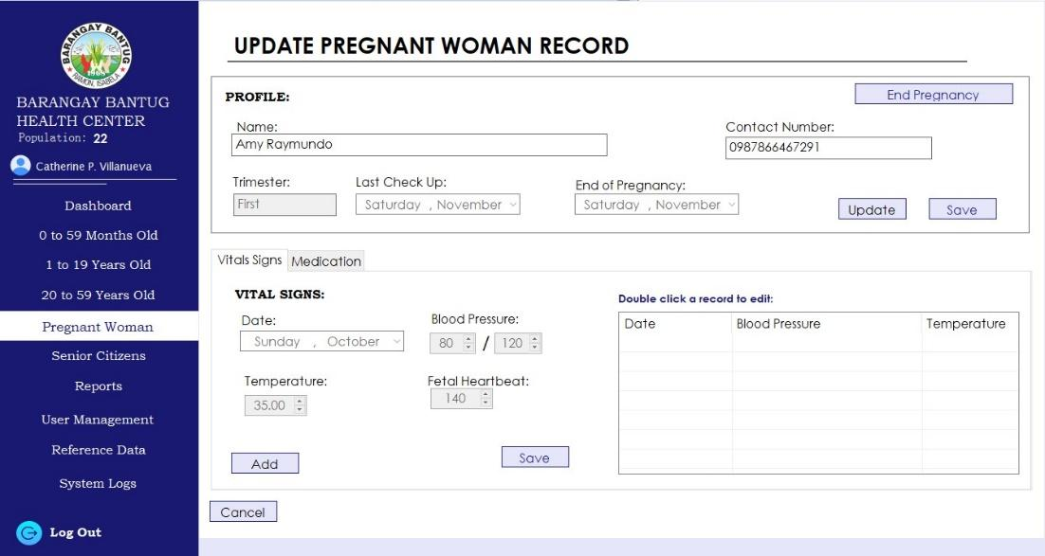

5.4.5 Masterlist for Senior Citizens
This Masterlist contains residents aged 60 years and above.

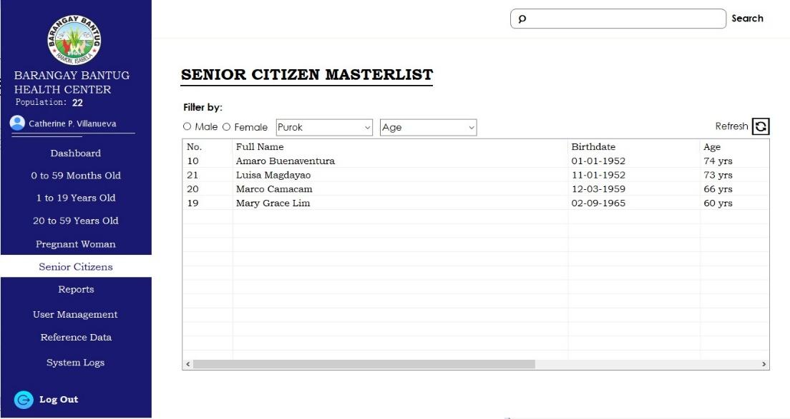

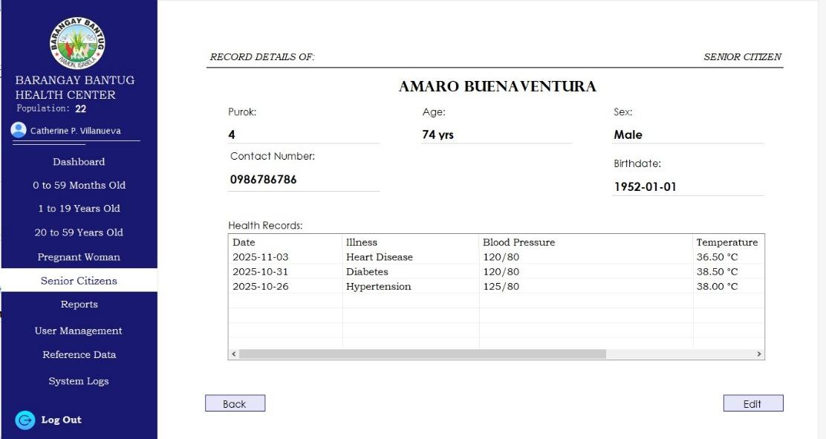

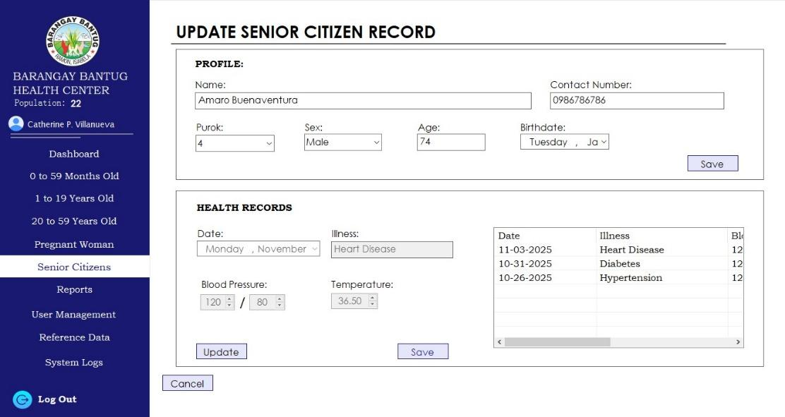

5.5 Reports Module
- Select the Reports on the left-side navigation.
- Select the desired report type using the available dropdown menu.
- Review the report in the preview screen.
- Select Print or Export to generate the report output.

Note: The Date is automatically generated in real time.
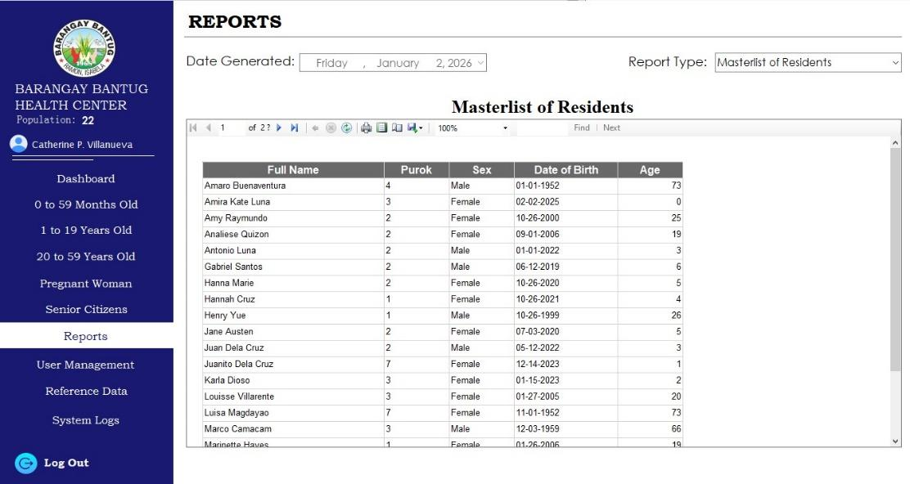

5.6 Administrator Modules and Controls
These modules are accessible only to users with Administrator privileges.

5.6.1 User Management
Functions include adding new system users, editing user information, and assigning and updating user roles.
- Select User Management from the left-side navigation menu.
- Enter the required information, including name, username, and password.
- Select the appropriate user role.
- To edit an existing user, double-click the user record from the list.
- Select Save to add a new user or apply changes to an existing record.
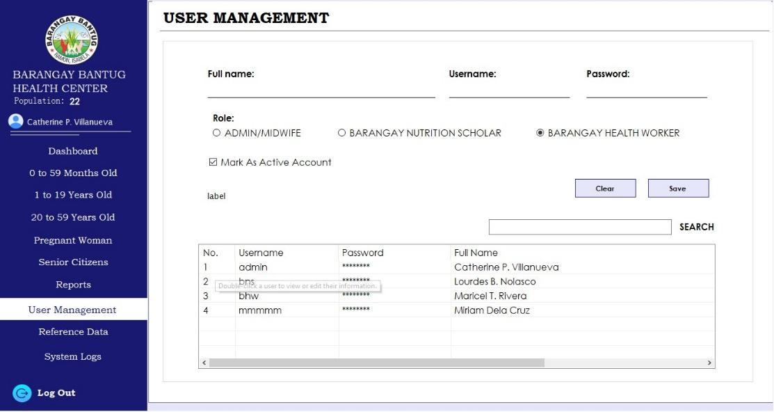

5.6.2 Reference Data Management
This module allows future expansion, such as PWD or Solo Parent classifications.
- Select Reference Data from the left-side navigation menu.
- Choose one of the three categories, then select Add to enable data entry.
- To edit existing data, double-click the record from the list.
- Select Save to add new data or apply changes to existing records.

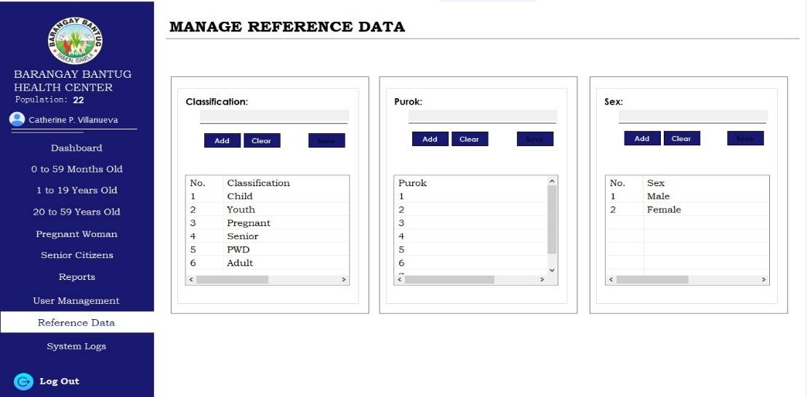

Note:
The Save button remains disabled until at least one valid input is provided.

5.6.3 System Logs
The System Logs module records user activities and system events for monitoring and audit purposes.
- Select System Logs from the left-side navigation.
- Select Sort to toggle between ascending and descending order.
- Use the date and time pickers to set the desired interval, then select Apply Filter.
- Select an Action from the drop-down menu to filter log entries.
- Select a User from the drop-down menu to view specific user activities.
- Logs automatically refresh, but the Refresh button may be selected for manual updates.
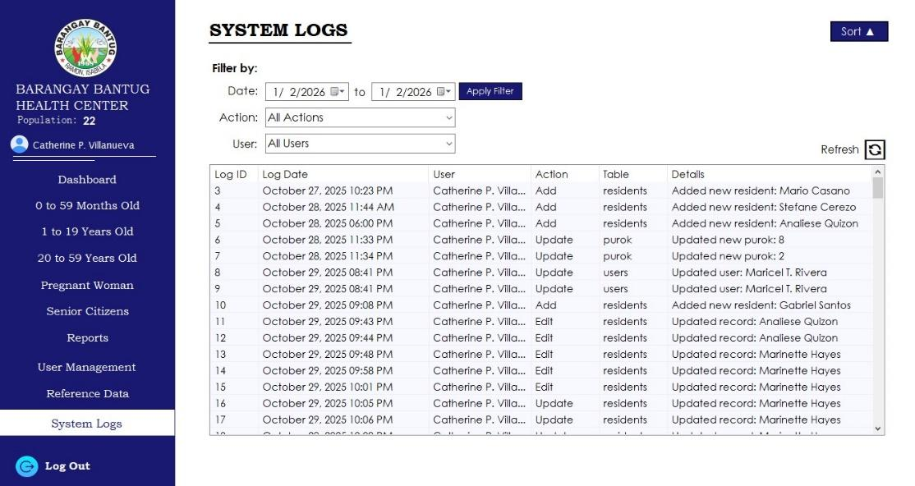

6. TROUBLESHOOTING GUIDE
ISSUE | POSSIBLE SOLUTION
Unable to log in | Verify credentials or contact the administrator
Data not saving | Ensure all required fields are completed
Report not printing | Check printer connection and settings
Guardian fields are not displayed | Confirm the resident's age is below 18

7. SECURITY AND PRIVACY GUIDELINES
- User accounts must not be shared.
- Users must log out after each session.
- Access is restricted based on assigned roles.
- The administrator must perform regular data backups.
- All data handling complies with the Data Privacy Act.

8. FREQUENTLY ASKED QUESTIONS (FAQ)
Q1: Who can add new users?
Only the System Administrator can manage user accounts.

Q2: Can resident information be edited?
Yes, but only specific fields are editable depending on the resident’s age group.

Q3: Why is the pregnancy option not available?
The resident must be female and at least 10 years old.

Q4: Can reports be exported?
Yes. Reports may be printed or exported for documentation purposes.

Q5: What happens if a resident’s age changes after editing?
The system automatically reclassifies the resident into the appropriate Masterlist based on the updated age.

Q6: Why are some records view-only and cannot be edited?
Certain modules restrict editing to specific fields to maintain data integrity and comply with system rules based on age group or classification.

Q7: What should be done if incorrect data was saved?
The user may update the record through the appropriate Update Details screen, provided they have the required access level.

Q8: Is the system accessible to unauthorized users?
No. The system requires valid user credentials, and access is controlled through role-based permissions.

End of System User Manual

